*Step 1 : create a chart by name ajay*

helm create todo

*step 2 : check the default values of the chart*

helm show values todo

*step 3 : check what helm is going to deploy*

helm install devops todo --dry-run

*step 4 : check the default nginx image version*

notice the nginx image that is going to install is nginx:1.16.0 and also port number 80 ( java app listens on 8080 so we need to modify

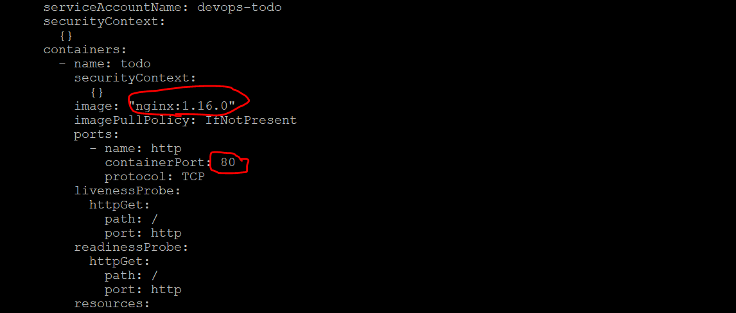

*step 5 : modify the nginx image with latest*

vim todo/values.yaml

Provide ur repo name

On line 44 – change to 8080 port and also to NodePort

Replace existing liveliness probe with below

helm install devops todo --dry-run

helm install devops todo

kubectl get svc

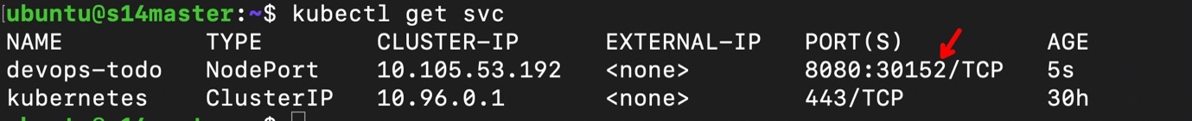

You access app via nodeip:port number

helm delete devops

====== lab completes =============